Charity partnership application process (2020-2021)

QBE’s approach to sustainability and community investment
As a company that helps people and businesses protect themselves and recover from risk, QBE has a focus on sustainability and this is an integral part of achieving our purpose, understanding the needs of our customers and ensuring the sustainability of our business. To provide quality solutions for our customers, we seek to understand the trends impacting them and the broader communities in which we operate.
As an insurance company, we are uniquely placed to help people in their times of need and our community investments reflect this. Our key avenues for community contribution across our global business divisions include:
- The QBE Foundation;
- Sponsorship and events; and
- Business initiatives (such as Premiums4Good).
The QBE Foundation
The QBE Foundation partners with impactful not-for-profits around the world to help people overcome poverty, strengthen their health and wellbeing, and to build more inclusive, sustainable communities. Our community approach is underpinned by employee engagement and the Sustainable Development Goals:
• Employee engagement: Local volunteering and giving activities that engage and support our employees to make a positive contribution to the communities in which they live and work;
• Sustainable Development Goals: Major partnerships and funding aligned with our priority Sustainable Development Goals (SDGs). These SDGs connect most closely to QBE’s purpose and strategic business priorities, and therefore are where we can have the greatest impact:
- SDG 1 – No poverty
- SDG 3 – Good health and well-being
- SDG 5 – Gender equality
- SDG 8 – Decent work and economic growth
- SDG 10 – Reduced inequalities
- SDG 11 – Sustainable cities and communities
- SDG 13 – Climate action

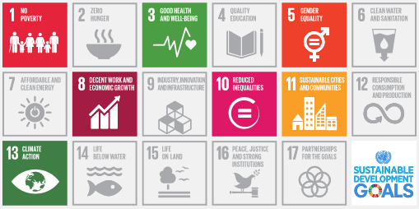

The partnership with QBE
From 2020 QBE will partner with two charities that align with one (or more) of the following SDGs:
- SDG 3 – Good health and well-being
- SDG 8 – Decent work and economic growth
- SDG 11 – Sustainable cities and communities
The two-year partnership is worth a minimum of £100,000 per year, for each partner and we are looking to partner on charitable initiatives that will have a demonstrable legacy beyond the duration of our partnership with them.
Through these partnerships we aim to create meaningful sustained impact in the communities in which we live and operate.

How to submit your application
Partnership applications should be submitted online via QBEeurope.com/charitypartnership2020
Should you have any questions, please contact QBEFoundationEO@uk.qbe.com

Please note, the size of the text boxes cannot be adjusted. Please keep within the space provided.
Charity partnership application form

About your organisation
Name of charity

Registered charity number
and country of domain

Year established

Address

Telephone number Contact name

Contact email address Website

Chairman Chief Executive

Number of full and part- Number of
time employees volunteers employed

Geographical locations

Indicate the need
supported by the

charity’s work

Summary of the charity’s

aims and objectives

The goal
Describe the goal that you would like us to achieve together. Emphasise the legacy that will be created to live beyond the two-year partnership.

Sustainability Development Goal alignment
How does your charity and this initiative align with our priority Sustainable Development Goals?

Partnership benefits
What benefits do you see our potential partnership having to your charity, and to QBE?

Partnership benefits
Beyond fundraising, describe how QBE and its employees can support the delivery of this initiative.

Engagement
How do you propose to manage the delivery of this initiative during the partnership and beyond?

Relevant experience
Provide examples of where you have worked on similar initiatives with a corporate partner.

Sponsorship
Please provide a breakdown with regard to how the funds will be allocated to deliver this initiative.

How will delivery of the initiative be measured, and ongoing legacy managed?

Strategic partnership with QBE
Given QBE specialises in helping businesses manage and offset risk; what additional benefit do you
envisage us being able to bring to this initiative.

Further information
Provide additional information which supports this application and current employee engagement with QBE employees.

Application authorisation
Signed on behalf of
the charity

Name

Title

Date

